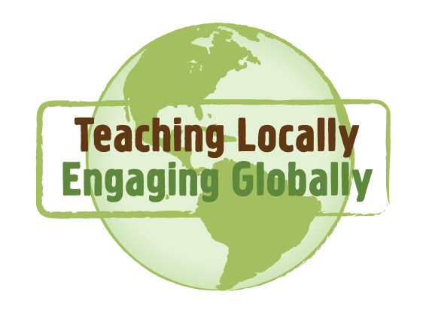
RLO Planning Sheet

Slide | Question/Information | Your Notes/Key Points
1 | What do you want to call your RLO?
2 | What do you want students to learn?
3 | What are a few key points about your topic/concept (bigger than the country you visited)?
4 | What are a few broad, general pieces of information about the country you visited (bigger than your RLO topic)?
5 | What are a few broad facts about the culture in the country you visited (bigger than your RLO topic)?
6 | What should your students know about your topic in the country you visited (big picture)?
7 | What should your students know about your topic in the country you visited (specific details)?
8 | [continued]What should your students know about your topic in the country you visited (specific details)?
9 | Who or what can you show in a video that would provide a context for your topic in the country you visited?
10 | How does the culture in the country you visited interact with the topic?
11 | What additional resources would be helpful to students and other faculty?
12 | Grant Information

